Te Whare Tapa Whā
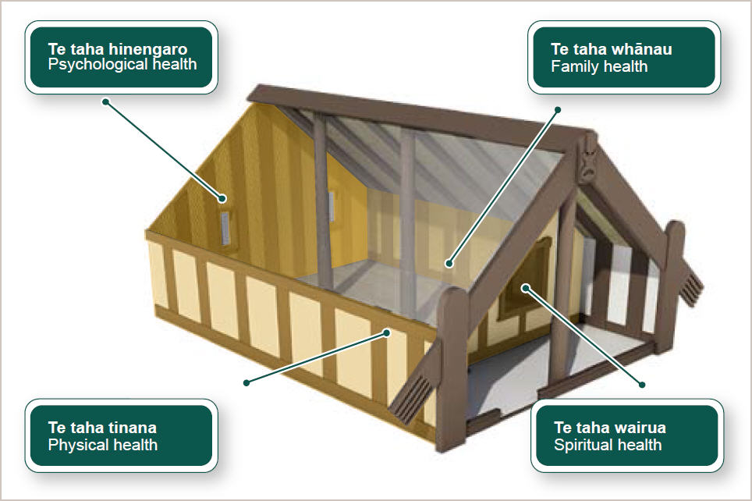
Dr Mason Durie developed the Te Whare Tapa Whā model in 1982.

The model can be applied to any health issue, whether it involves physical or psychological well-being.

The Māori philosophy toward health is underpinned by four dimensions representing the basic beliefs of life.

Te taha hinengaro Psychological health | Focuses on emotions. The mind and body are inseparable. Communication through emotions is important and more meaningful than the exchange of words. For example, someone who is unhappy in their career or work may manifest this in physical illness.
Te taha wairua  Spiritual health | Recognised as the essential requirement for health and well-being. Without spiritual awareness an individual may lack well-being and be more prone to ill health. Wairua explores relationships with the environment, people and heritage. Spiritual awareness is key to making effective career decisions.
Te taha tinana  Physical health | Focuses on physical well-being and bodily care. Tinana suffers when a person is under emotional stress, or is unwell. Pain in different parts of your body is tinana communicating what is going on consciously or unconsciously. For example, someone who is stressed or unhappy in their career or work may be more likely to become physically ill.
Te taha whānau  Family health | The most fundamental unit of Māori society. Whānau are clusters of individuals descended from a fairly recent ancestor and may include up to three or four generations. The beliefs, expectations or opinions of the whānau can have a major impact on the career choices that an individual makes.

The wharenui (meeting house) is the symbol used to illustrate these dimensions of well-being. Just as each corner of the house must be strong and balanced to hold its structure, each dimension of well-being must be balanced for health to exist. This philosophy may be used to approach all areas of wellness in life, career management included.

To increase likelihood of making successful transitions, career education and guidance needs to build on clients’ knowledge of themselves and their potential for development. Developing self-awareness is key to creating balance and harmony in all aspects of life, including career development.

