Employers’ Toolkit:
Engaging with young people.

Employers’ Toolkit index

1. How engagement works
2. Getting ready to engage with students

3. Engagement activity plan
4. Measure your success

5. Who can help directory
6. Engaging with young people – what to expect

7. Employer tips for school presentations

8. Employer tips for industry events and expos

9. Checklist for industry events and expos
10. Work shadowing plan

11. Health and safety checklists for visits and work experience

12. Risk assessment form

13. Student health and safety induction checklist

14. Seven employability skills checklist

15. Induction checklist

16 Career conversation starters

17. Career mentoring conversation starters

18. Career development checklist
19. Career development plan

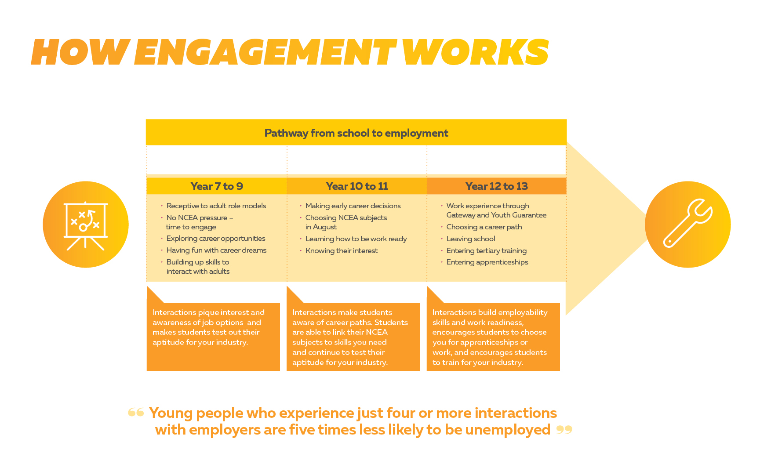

Getting ready to engage with students
Engagement health check

Why do this check?
- Tap into the emerging pipeline to meet skills needs for your business and the industry as
a whole.
- Save time and money with a planned, connected approach that helps you measure outcomes.
- Raise the profile of your industry to encourage young people to learn, live and work in
your region.
- Access tools and resources from one reliable and professional source.

Why are you doing this?
Engagement health check
Create a team of interested people to work with, decide why you are doing this. What problem are you trying to solve?
Get support/buy-in from senior managers.

What problems are we trying to solve by attracting young people to our business/industry? | What are our skills needs over the next 5 years? | What would success look like?

What are we already doing?
Engagement health check
You may already be interacting with schools and students – is it working? Is it giving you access to the right students at the right time to build your skills pipeline?
What do we do now? | Who makes it happen?  Which schools?  How many students in the last 2 years? | How often and what resources do we use?  How do we know it works? | What works? | What doesn’t work? | What would make it better?

Engagement activity action plan

Which activities are a priority for your business to help you bridge the skills gap?

Activity | Why? What’s the purpose? | When? Frequency? | Who is the target audience? | What support do I need (internal and external)
e.g. Presentation at assembly | Awareness of workplace | Term 3/Every term | Year 10 | Ferndale High career advisor, Matt from Marketing

Classroom talk

Sponsorship of event

Sponsorship – ongoing

Career expo

Industry Big Day Out event

Workplace visit

Industry field event

Gateway work experience

Work experience

Job shadowing

Career mentoring –
face to face

Career mentoring – online

Mock job interview

Curriculum planning

Resource creation

Industry association planning

Work inspiration programme

STAR programme

Internship

Cadetship

Career champions

Donations

Virtual visits/video

Competitions e.g. Young Enterprise Scheme

Youth Employability Programme (YEP)

(Adapted from Construction Industry Council employer’s toolkit)

Measure your success
Review your activities tool

The bottom line – how do you know it is working? How will you improve? Whose support do you need?
Activity | Success measures | Results | Improvement actions | What next?  By when?

Who can help you directory
Agency | Assistance | Contact details
Careers New Zealand | - Work Inspiration  - Building connections with schools  - Industry, job and career advice  - Advice on working with young people  - Labour market information  - Industry field events  - Career expos  - Industry big day outs  - Resource support  - Toolkits | 0800 222 733  careers@careers.govt.nz  www.careers.govt.nz  workinspiration.nz
Building and Construction Industry Training Organisation  (BCITO) | - Help with Gateway  - Industry information  - Labour market information  - Employer development grants  - Help finding apprentices  - Apprentice agreements  - Apprentice support and bookwork | 0800 4 BCITO  info@bcito.org.nz  bcito.org.nz

Careerforce (Community services and health) | - Workplace training  - Literacy and learning support  - Subsidies advice  - Industry information | 0800 277 486  info@careerforce.org.nz  www.careerforce.org.nz
Chambers of Commerce | - Networking  - Recruitment  - School relationships  - Cadetmax  - Career Start  - HR advice  - Business support line  - Resources | 0800 543 543  info@wecc.org.nz  www.newzealandchambers.co.nz
Comet | - Youth employability programme  - Employability skills support | 09 307 2101  www.cometauckland.org.nz
Competenz | - Industry information  - Labour market information  - Help finding apprentices  - Apprentice agreements  - Apprentice support and bookwork | 0800 526 1800  info@competenz.org.nz  www.competenz.org.nz
DairyNZ | - Workforce planning  - Recruitment advice  - HR Toolkit  - Career mentoring  - Industry events  - Industry information  - Labour market information | 0800 4 DairyNZ  info@dairynz.co.nz  www.diarynz.co.nz
Employers and Manufacturers Association | - HR advice  - Recruitment advice  - Workplace training  - Labour market information | 0800 300 362  advice@ema.co.nz  www.ema.co.nz
Employment New Zealand | - Recruitment advice  - HR advice  - Career mentoring advice  - Induction advice | 0800 20 90 20  www.employment.govt.nz
Future in tech | - Tech ambassadors  - Links with schools  - Industry information  - Labour market information  - Industry events | (04) 473 2023  enquiries@futureintech.org.nz  industry.futureintech.org.nz

Gateway (Tertiary Education Commission) | - Gateway work experience programme | Contact your local school’s Gateway Co-ordinator  Or  0800 601 301  sectorhelpdesk@tec.govt.nz  www.tec.govt.nz
Horticulture New Zealand | - HR advice  - Recruitment advice  - Workplace training  - Labour market information | (04) 472 3795  info@hortnz.co.nz  www.hortnz.co.nz
Māori and Pasifika Trades Training (MBIE) | - Recruitment assistance  - Links with schools  - Building connections  - Subsidies  - In-work support | (04) 901 1499  info@mbie.govt.nz  www.mbie.govt.nz
Mayor’s Taskforce for Jobs | - Building connections  - Bridging the gap  - Resources | Daniel Henderson  04 924 1200  info@mtfj.co.nz  www.mayorstaskforceforjobs.co.nz
MITO (Motor industry) | - Industry information  - Labour market information  - Help finding apprentices  - Apprentice agreements  - Apprentice support and bookwork  - Work experience | 0800 88 21 21  www.mito.org.nz

HITO (Hair and Beauty) | - Help with Gateway  - Industry information  - Labour market information  - Apprentice bookwork | (09) 579 4844  (04) 499 5150  (03) 338 5376  info@hito.org.nz  www.hito.org.nz
NZ Marine and composites ITO | - Industry information  - Labour market information  - Help finding apprentices  - Apprentice agreements  - Apprentice support and bookwork | 0800 600 242  training@nzmarine.com  www.nzmacito.org.nz
Primary Industry Training Association | - Industry information  - Labour market information  - Help finding apprentices  - Apprentice agreements  - Apprentice support and bookwork  - Workplace training | (04) 801 9616  info@primaryito.ac.nz  www.primaryito.ac.nz
Service IQ | - Industry information  - Labour market information  - Help finding apprentices  - Apprentice agreements  - Apprentice support and bookwork  - Literacy and learning support  - Qual link  - Workplace training | 0800 863 693  intel@ServiceIQ.org.nz  www.serviceiq.org.nz

Skills Active Aotearoa | - Industry information  - Labour market information  - Workplace training  - Workforce planning | 0508 4 SKILLS  info@skillsactive.org.nz  www.skillsactive.org.nz
Skills Highway (Tertiary Education Commission) | - Workplace literacy, numeracy and communication skills help | 0800 601 301  www.skillshighway.govt.nz
Te Puni Kōkiri | - Cadetships | 04 819 6000  info@tpk.govt.nz  www.tpk.govt.nz
The Salvation Army | - Training tailored to your work needs  - Recruitment  - In-work support  - Employability skills  - Ex-offender placements | 0800 437 587  Educationandemployment.org.nz
The Skills Organisation | - Industry information  - Workplace training | 0508 SKILLS  support@skills.org.nz  skills.org.nz

Work and Income | - Recruitment services  - Pre-employment drug testing  - Wage subsidy  - In-Work Support  - Modification Grant  - Industry partnerships  - Employer advice line for disability and health-related questions  - Work experience support  - Training funding  - Limited Service Volunteer programme | 0800 778 008  www.workandincome.govt.nz
Worksafe New Zealand | - Health and safety in your workplace | 0800 030 040  info@worksafe.govt.nz  www.worksafe.govt.nz
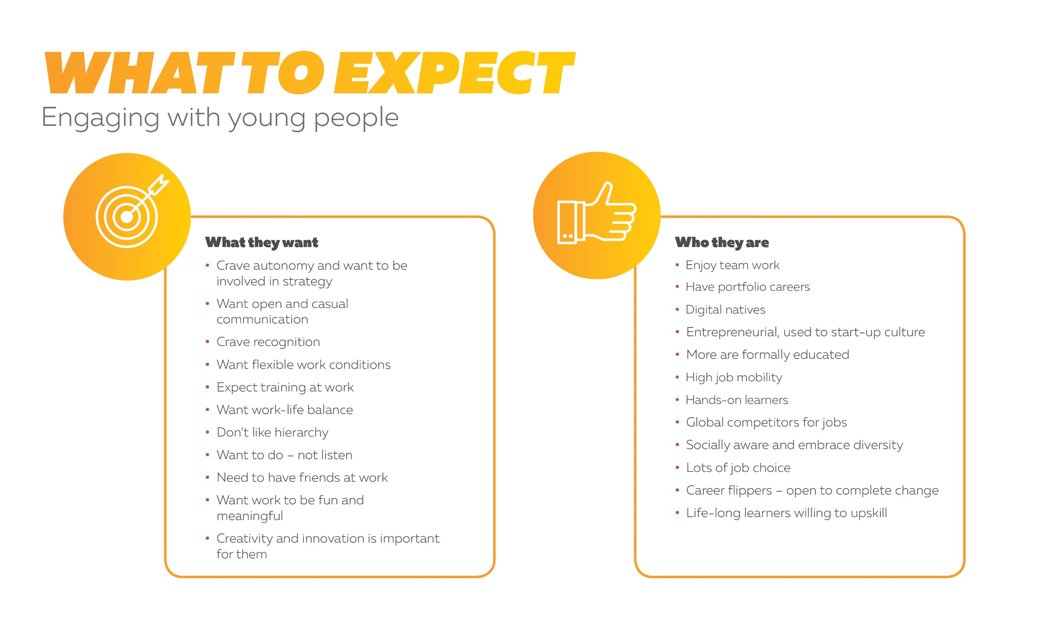

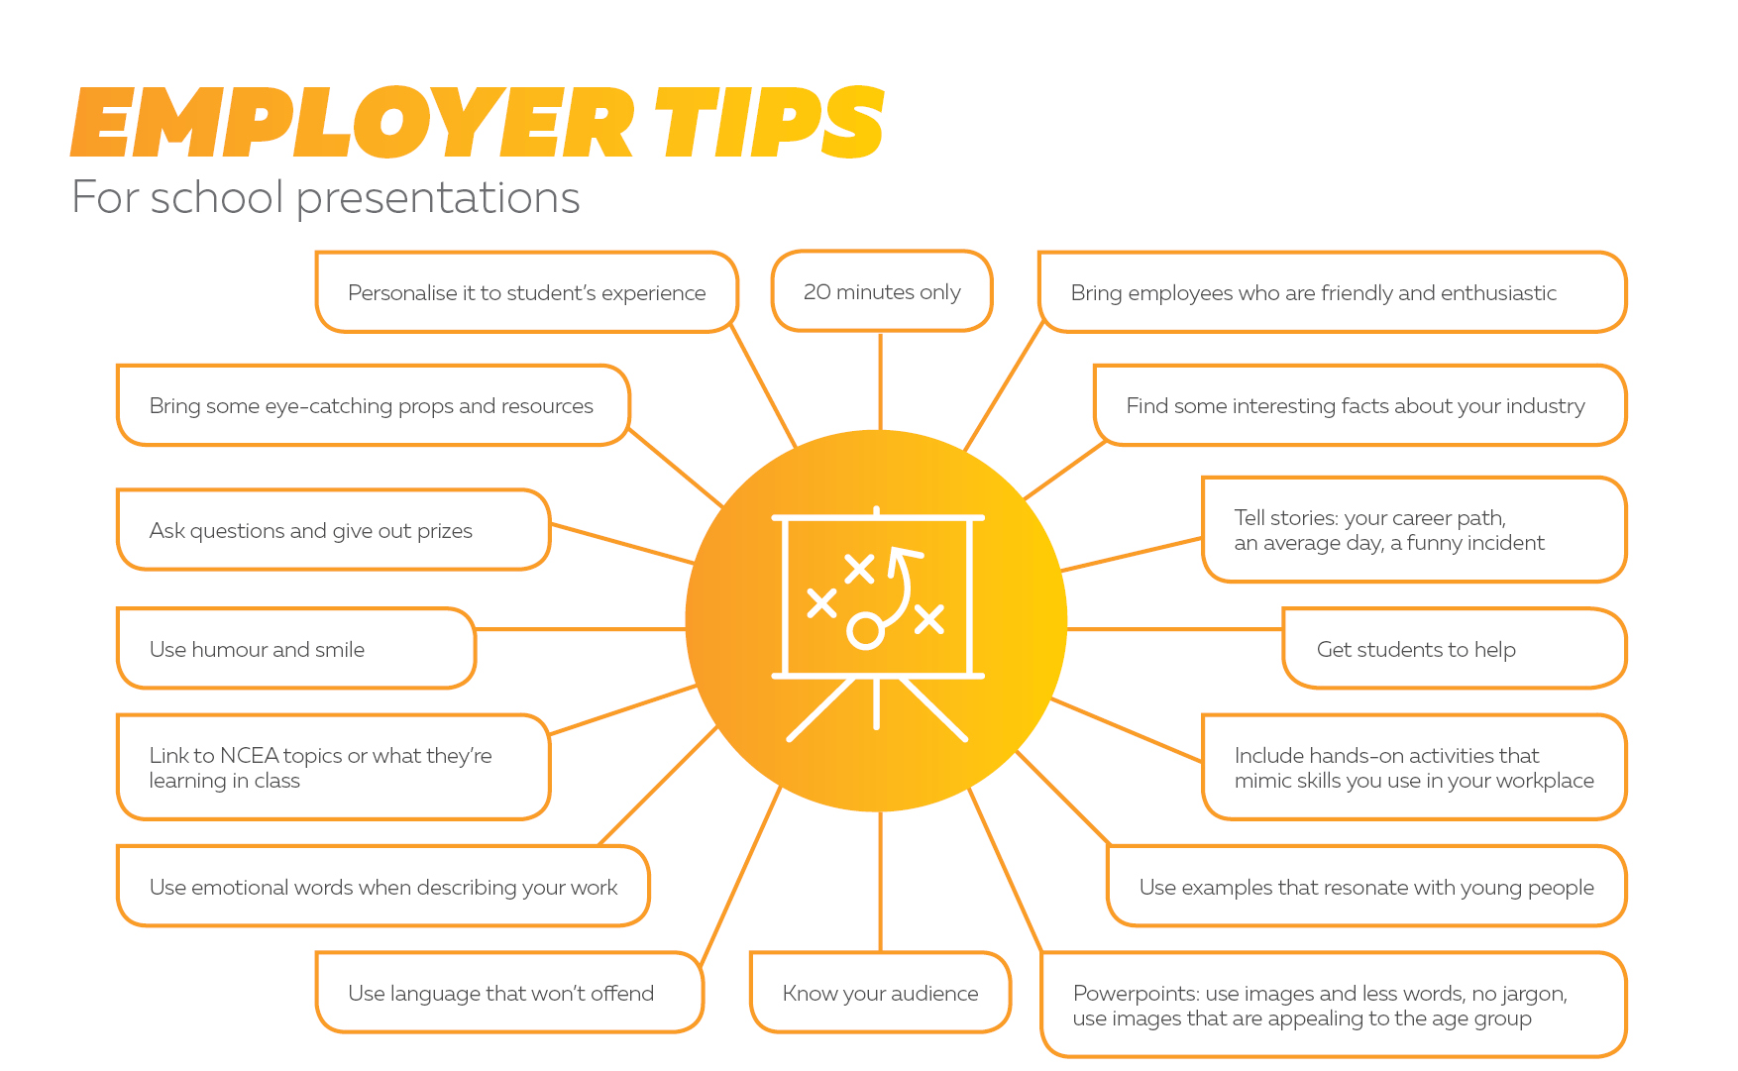

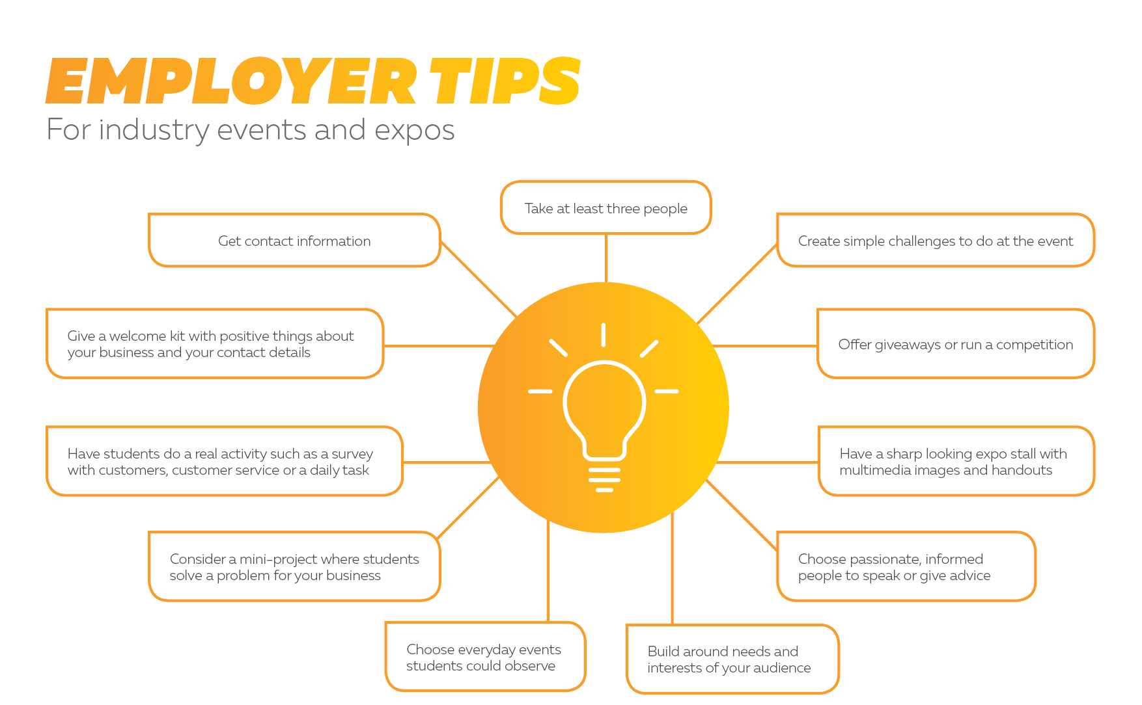

Checklist for industry events and expos

Before the event - First steps
Choose the objective of the event
Find out who the audience will be
Make a planning team
Contact the event organisers
Contact your industry training organisation or Careers New Zealand
Make a budget – include event costs, venue, marketing, printing, multimedia, travel
Plan a timeline with deadlines
Book place in event
Check the venue details – include Wi-Fi, power-points, parking, food, safety, visibility
Create a media plan
Before the event - Planning
Choose the staff who will take part in the event – include social media filming or posting
Plan activities to do at the event
Make an agenda for the day
Plan marketing materials such as the stand, posters, hand-outs, give-aways, videos
Make a health and safety risk assessment plan
Meet with teacher/careers advisor/Careers New Zealand
Plan giveaways or competitions
Plan multi-media information like video clips
Decide if you will gather student information and how you will gather it
Choose which technology you will use
Clarify event facilities and timings – including technology, set up times, stall location
Before the event - Preparation
Create or order marketing materials, name tags and give-aways
Create videos or presentations
Create or gather equipment/resources for activities
Create contact forms/entry forms for students to complete
Create competition rules/legal notice
Purchase prizes
Book travel, accommodation and transport for out-of-town staff
Create social media posts, advertisements and press releases

Before the event: Ready to go
Create an elevator pitch to sell your industry
Confirm attendance from school students if applicable
Collect health and safety/ media permission forms for students if applicable
Post press releases, advertising and social media
Run through agenda for the day with staff participants
Run through technology or activities for the day
During the event
Move around the booth and talk to students
Ask questions, keep tone light and humorous
Have one staff member in charge of technology and giveaways
Have all staff members monitor safety
Take note of how other stallholders engage with students
Collect and store student details safely
Keep tables clean and uncluttered
Post on social media and film and take photos for media later
Make a note of potential talent

After the event
Report on what you learned from the event
Send emails to participants with thanks and a call to action/offer to engage
Meet with career advisor/teacher to gauge success, plan to develop potential talent, get feedback, plan follow-up activities
Post event video or photos with permissions to social media

(Adapted from Hru.gov ‘Preparation Checklist for Job Fairs and Recruitment and Hiring Events template’)

Work shadowing plan

Activity | Time | Location | Who
Greetings | 08:30
Induction  - Building facilities  - Agenda of the day  - Guidelines for observing  - Health and safety  - Materials – observation book, safety gear | 08:45
Activity 1  Student observes a work activity.  Activity = e.g. welding | 09:00-10:00
Morning tea  Morning tea with staff members | 10:00-10:15
Activity 2  Activity = | 10:15-11:15
Career conversation  Staff to talk about their career path into your workplace. Talk to the student about their career ideas and plans for when they leave school. | 11:15-12:00
Lunch | 12:00-12:30
Activity 3  Student observes or takes part in a work activity.  Activity = | 12:30 – 1:30
Activity 4  Student observes or takes part in a work activity.  Activity = | 1:30 – 2:30
Round up  Student/teacher share what they learnt, ask questions, debrief. | 2:30 – 3:00

Work Inspiration website – make work experience easy and try Careers New Zealand employer-led work exploration programme

Health and safety checklist for visits
and work experience

Employers are responsible for the health and safety of students who visit or do work experience activities at your workplace. Students need to take reasonable care for their own health and safety and the health and safety of others in your workplace.

Schools will have their own protocols and forms, so work closely with them.

Task: Health and safety checklist | Who is responsible | Notes | Signature | Date
Have a health and safety policy
Have a risk assessment plan
Have a plan if student is sick or injured or does something risky or inappropriate
Have a process for reporting hazards
Have a process for emergency situations and a first aid kit
Have a place to record incidents and hazards
Have key health and safety people and someone who can deliver first aid
Have a health and safety induction programme that includes:
- emergency and evacuation procedures
- safe and correct work practices
- safe use of equipment
- possible hazards and how to identify them
- how to report hazards
- hygiene
- protective clothing and safety gear.

Have all possible hazards identified, controlled and pointed out to visitors and workers
Enough staff to supervise students closely
Health and safety measures been communicated to school before visit
Agreements for work experience or permission forms for workplace visits signed by students

Common workplace hazards identified and minimized including:
- handling tools and equipment
- slips, trips and falls
- machinery and vehicles
- noise/vibration
- bullying/harassment
- stress/fatigue
- long hours
- ventilation and dust
- hazardous substances
- exposure to disease
- contact with electricity
- heavy lifting.
Have employers who will supervise the students do police safety checks

- Education New Zealand website – find information on health and safety obligations for work experience

Risk assessment form

Use the risk assessment form to keep a record of the risks you identified and fixed.
Teacher: | Year:
Event:
Class/Young person:
School address/Home address:
Business address:
Possible major hazards:
Action required:
Action taken:
Risk assessment undertaken by : Date:

Name: Signature:

Student health and safety induction checklist

Students can fill this in themselves and have it checked by an employee.

Task: Student health and safety induction checklist | Notes | Signature | Date
I understand that I must take reasonable care of my
own health and safety
I understand that I must take reasonable care of the
health and safety of others
I know what to do in an emergency situation
or evacuation
I know where the exits and the toilets are
I know how to get first aid
I know what a hazard is and how to report a hazard
I know how to report an incident
I know the right way to behave at work to keep healthy and safe
I know what equipment I’m not allowed to use
I know what clothing or safety equipment I need to use
I know that I can refuse to do things that I think
are unsafe
I know who to talk to about any health and safety concerns I have
I completed a health and safety induction
Signed off by: | Date:

Seven employability skills checklist

Check all the skills your intern or employee has, or the ones they need to work on. Write down examples of their skills
in the notes.
Employability skill | Rating |  | Notes
1. Positive attitude  - Is positive and has a ‘can do’ attitude  - Is optimistic, honest and shows respect  - Is friendly and enthusiastic  - Is motivated to work hard towards goals | O.K | Needs work

2. Communication
- Understands and reflects on the way they communicate and how it affects others
- Asks questions when unsure or unclear
- Understands how employees, employers and customers communicate
- Speaks, listens and shares ideas appropriately

3. Team work
- Works well with others to complete tasks and meet goals
- Contributes to developing new ideas or approaches
- Works well with others of different genders, cultures or beliefs
- Recognises the authority of supervisors and managers and follows directions

4. Self-management
- Arrives at work on time with appropriate clothing and equipment to complete a work day
- Understands and reflects on their own words, actions and behaviour and how these affect others
- Shows commitment and responsibility
- Is dependable, follows instructions and completes assigned tasks
- Is responsible for their own health and wellbeing and follows health and safety guidelines

5. Willingness to learn
- Willing to learn new tasks, skills and information
- Curious and enthusiastic about the job, organisation and industry
- Looks for opportunities to work more effectively to make the business better
- Accepts advice and learns from feedback

6. Thinking skills (problem solving and decision making)
- Identifies and assesses options before making a decision
- Recognises problems and uses initiative to find solutions
- Thinks about consequences before they act
- Recognises when they need to seek advice

7. Resilience
- Adaptable and flexible in new and changing situations
- Handles challenges and setbacks and does not give up
- Able to seek support and help when needed
- Recognises and accepts mistakes made and learns from them

Induction plan

Induction activity | Level of commitment | When | Who | Notes
Welcome and introductions, meet buddy |  |  |  | If using a buddy
Health and safety briefing and paperwork |  |  |  | Sign health and safety forms
Building tour – include break rooms and toilet
Security keys and process
Explain programme and timetable
Set-up with equipment or safety gear
Staff morning tea
Discuss NCEA credits/Gateway workbook |  |  |  | If doing Gateway
Authentic hands on activity 1
Licence check |  |  |  | If necessary for role
Career goals talk
Authentic hands on activity 2
Regular check - ins
Breaks and lunch
End of day check - in
End of day - discuss next day

Career conversation starters

Career conversations are relaxed conversations about career pathways and progression. Use this for assessing whether a student is a good fit for work experience, an apprenticeship, or work.

Set-up
- Comfortable set-up. Students must be aware of the reason for the meeting.
- Be aware of the content in their CV.
- Be aware of how you see them fit with your business goals.
- Understand what you have to offer them to develop their skills.
- Start with general conversation and use open- ended questions using ‘What’, ‘How’, ‘When’ or ‘Tell me about.’
- Talk about next steps at the end of the conversation.

Keep in mind
- Students may not be used to this style of communication and may take time to answer.
- Students are used to adults as authority figures at school and may be nervous.

Career conversation starters
- What do you enjoy doing at school and after school?
- I can see from your CV that you …. Can you tell me …?
- I was interested to see that you …. How did that happen?
- What are the things you are seeking most in a career?
- How will this job help you get what you want?
- What have you done on your own to help you towards your career goals?
- What things are influencing your ideas about your future career?

Career mentoring conversation starters

Use this for mentoring a work experience student to encourage them to choose your industry when they leave school.

Set-up
- Comfortable set-up. Students must be aware of the reason for the meeting.
- Allow up to one hour.
- Be aware of the content in their CV.
- Be aware of when they have been fully engaged during work experience. What skills were they using?
- Be aware of how you see them fitting with your business goals.
- Understand what opportunities you have to offer them.
- Start with general conversation and use open ended questions using ‘What’, ‘How’, ‘When’ or ‘Tell me about’
- Know what your business can do to support their goals.
- Talk about next steps at the end of the conversation.

Keep in mind
- Students may not be used to this style of communication and may take time to answer.
- Students are used to adults as authority figures at school and may be nervous-

Career conversation starters
- What do you enjoy doing at school and after school?  - I can see from your CV that you …. Can you tell me …?  - I was interested to see that you …. How did that happen?  - What are the things you are seeking most in a career?  - What have you enjoyed doing most in work experience? | - What have you done on your own to help towards your career goals?  - What things are influencing your ideas about your future career?  - What help do you need to make a decision about your future career?  - If you got the chance to work here, what do you see yourself doing?  - What would you like to do more of? What would you like to do  less of?

Career development checklist

Use this to plan to assess what development you can offer in your workplace.

Development activities | Option (Y/N)? | Details
External short courses
Qualification support - financial
Qualification support - time
Internal short courses
Internal online courses
Membership of professional organisations - financial
Membership of professional organisations - time
Industry or network events and conferences
Work shadowing
Temporary assignments or secondments
Regular performance discussions
Internal coaching
External coaching
Professional supervision
Mentoring
Internal vacancy notification
Promotions
Trainee or cadetships
Voluntary work
Flexible work
More autonomy
Job rotation
Project work

Career development plan

Use this to plan career development needs in your workplace.

Skills needed | By when | Short-term  activities | Medium-term activities | Long-term  activities | Resources needed | People
e.g. Construction management | End 2020 | Work shadowing | Secondment  Project work | Mentoring  NZ Certificate | Course fees support  Time support  Trainers | Hine Kowhai

More information

Careers New Zealand can help you engage with young people.
Visit our website careers.govt.nz/employers
Call us on 0800 222 733
Email us at careers@careers.govt.nz

